Full Name- Poonam Langote
Submission Date-21/05/2026
AWS Region Used ( US-east-1)

Capstone Project 1: AWS Cloud Practitioner
Static Portfolio Website with S3, Cloud Front-Free Hosting, Monitoring & Security
Project Overview
In this capstone you will build and secure a complete static portfolio website on AWS. You will combine S3 hosting, IAM security, CloudWatch monitoring, CloudTrail auditing, and billing protection into one coherent project - exactly the kind of small-scale but complete infrastructure a junior cloud engineer would build and hand over to a client or manager.

User portfolio-admin created
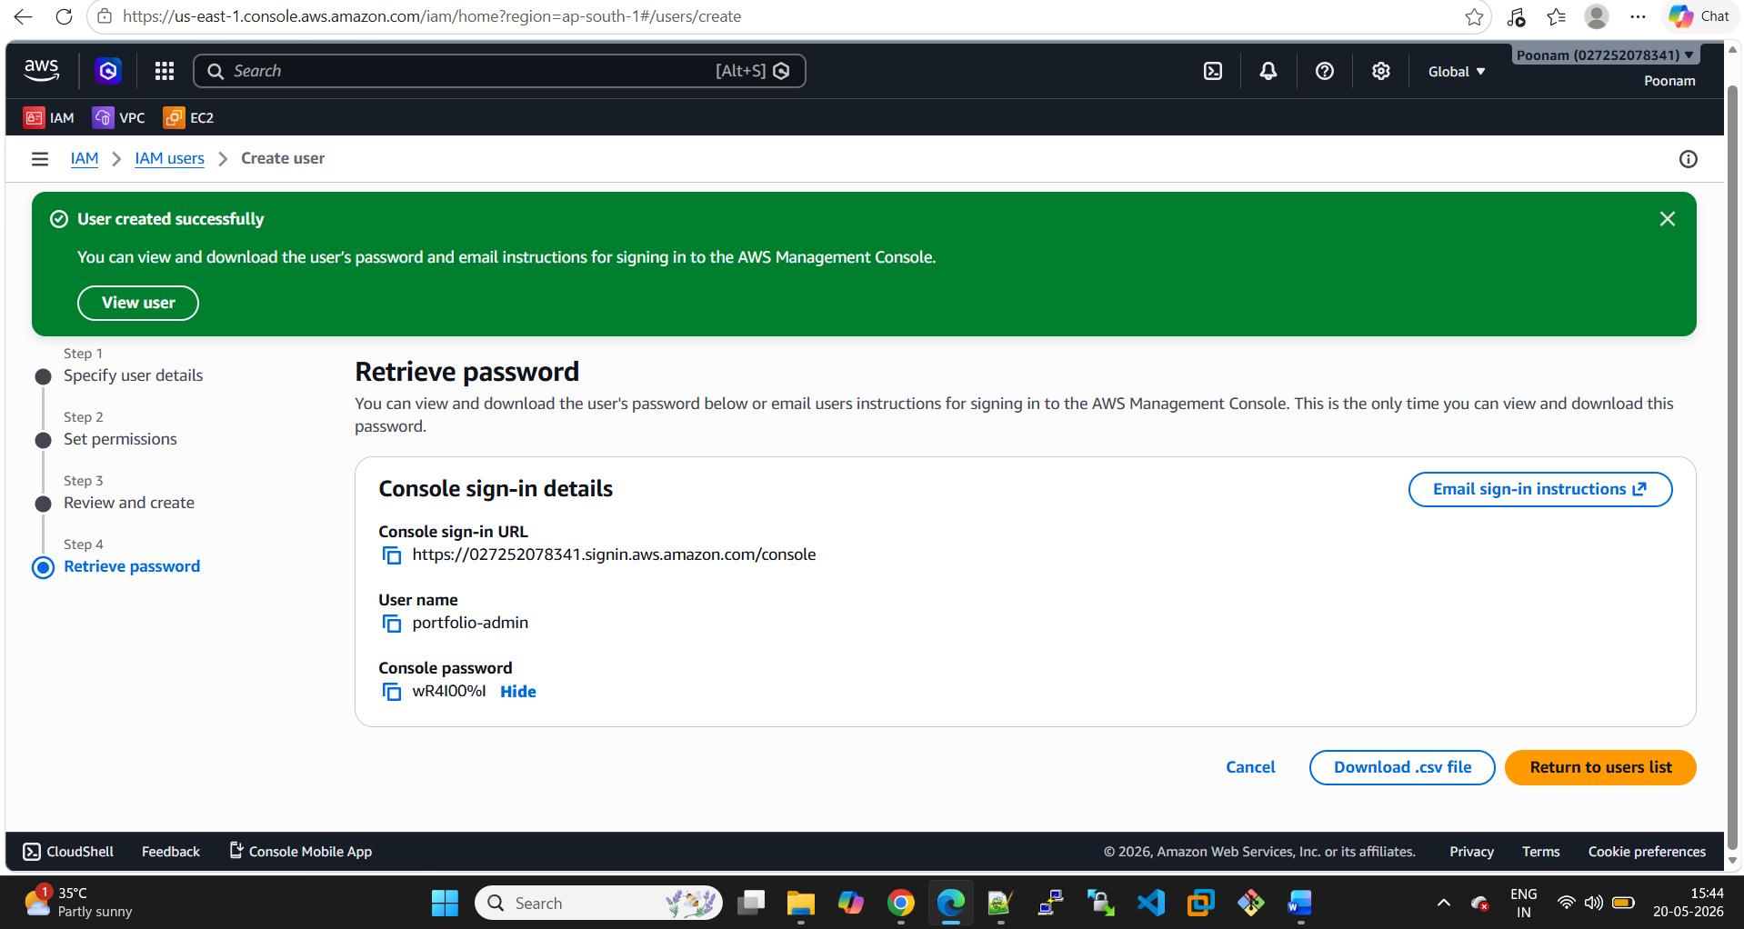
MFA enabled
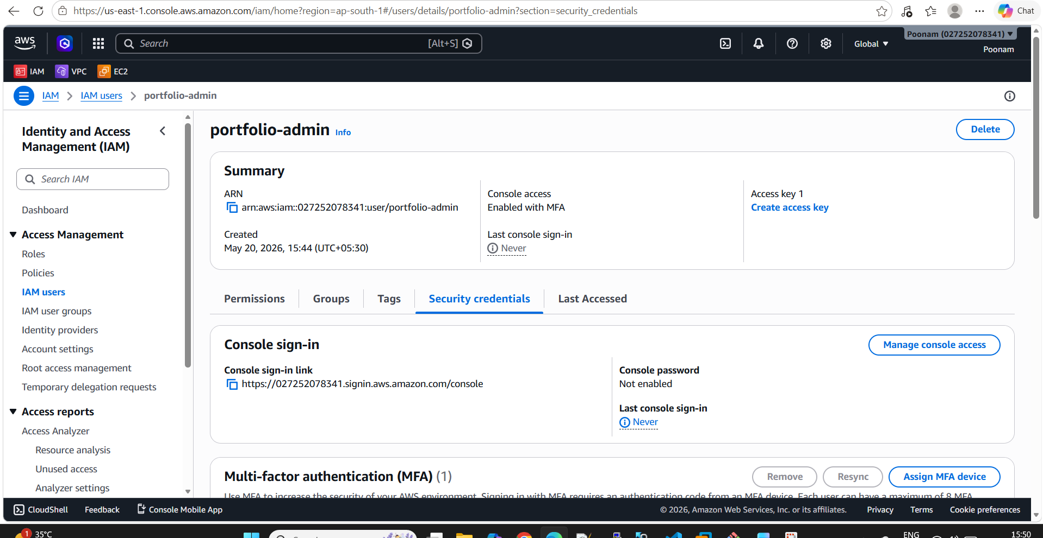
Group created
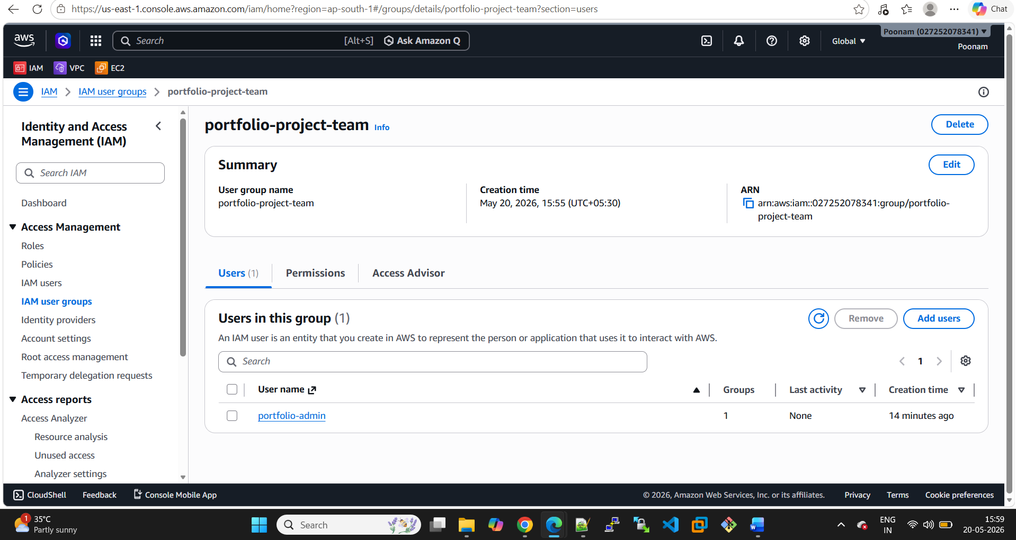
Password Policy Configured
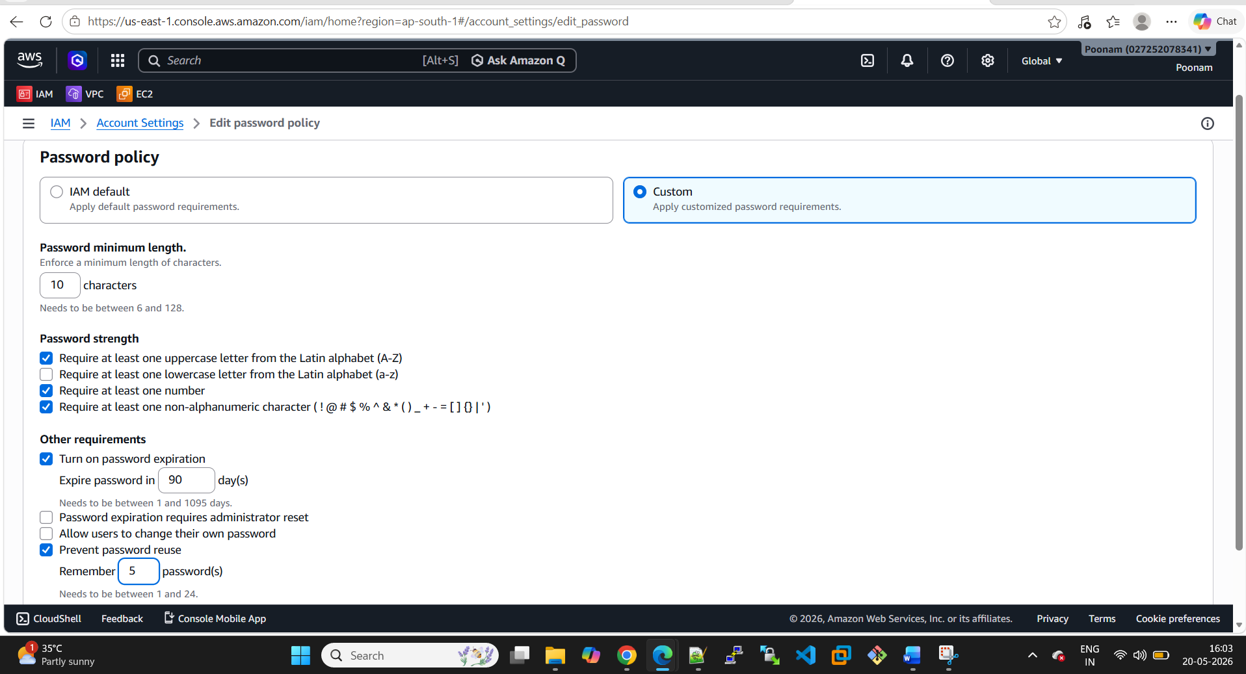
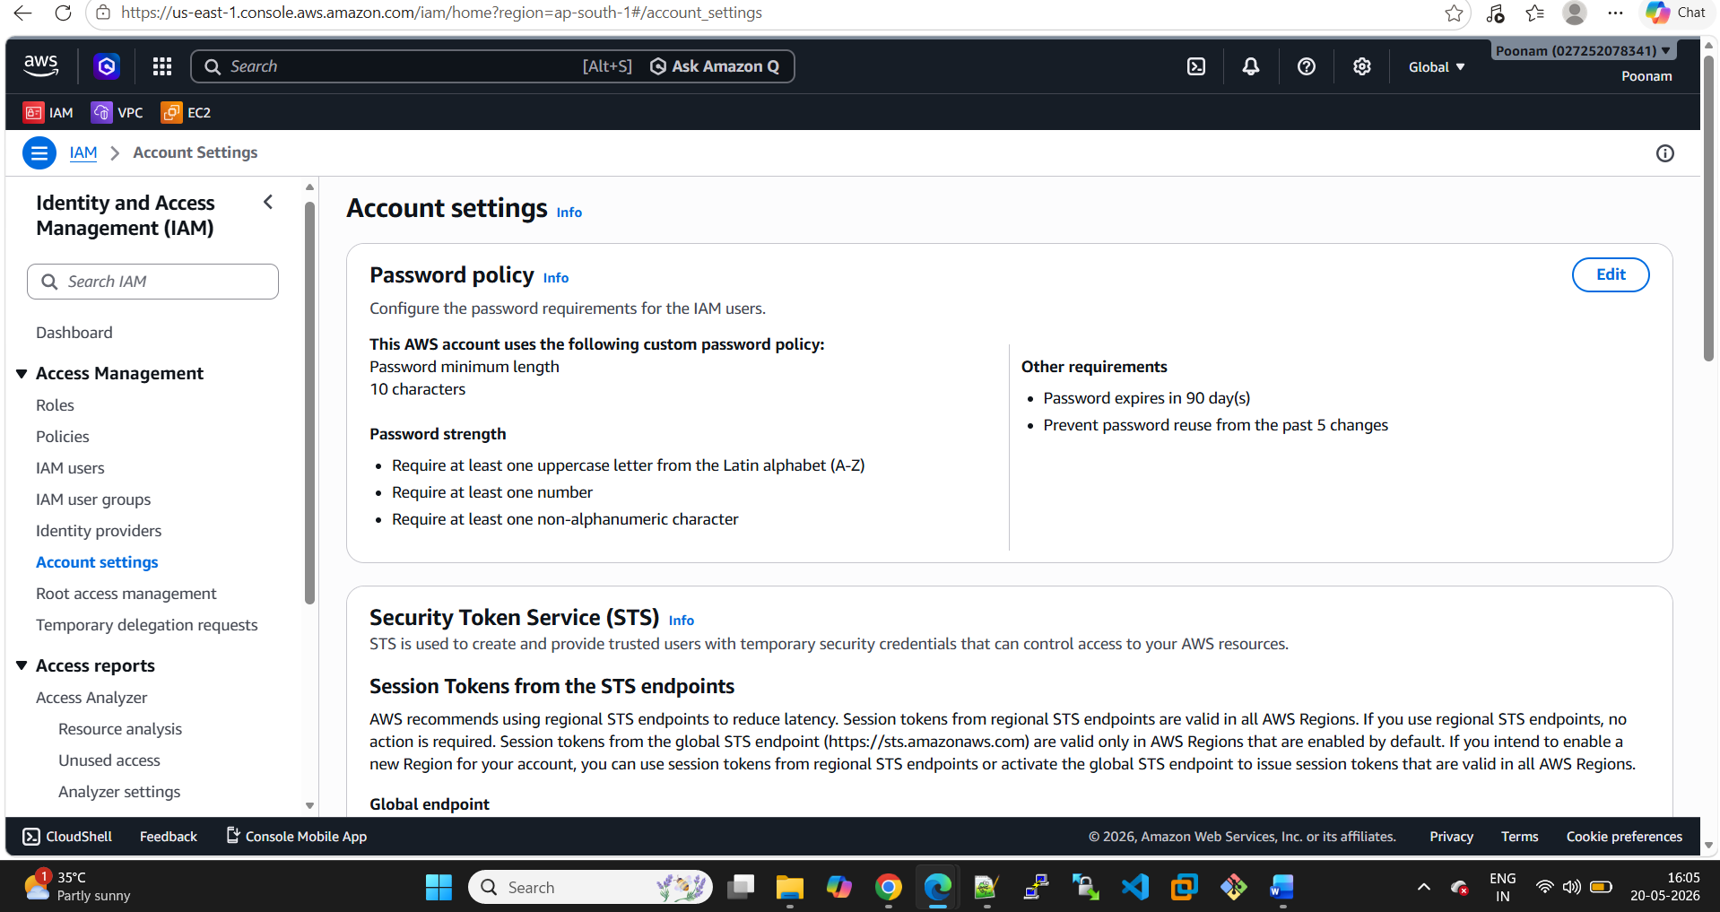

Buckets created.
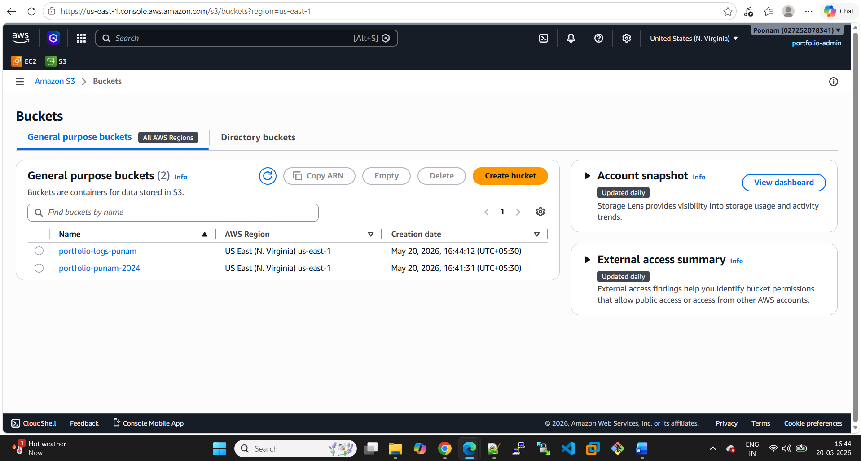
Server access logging enabled
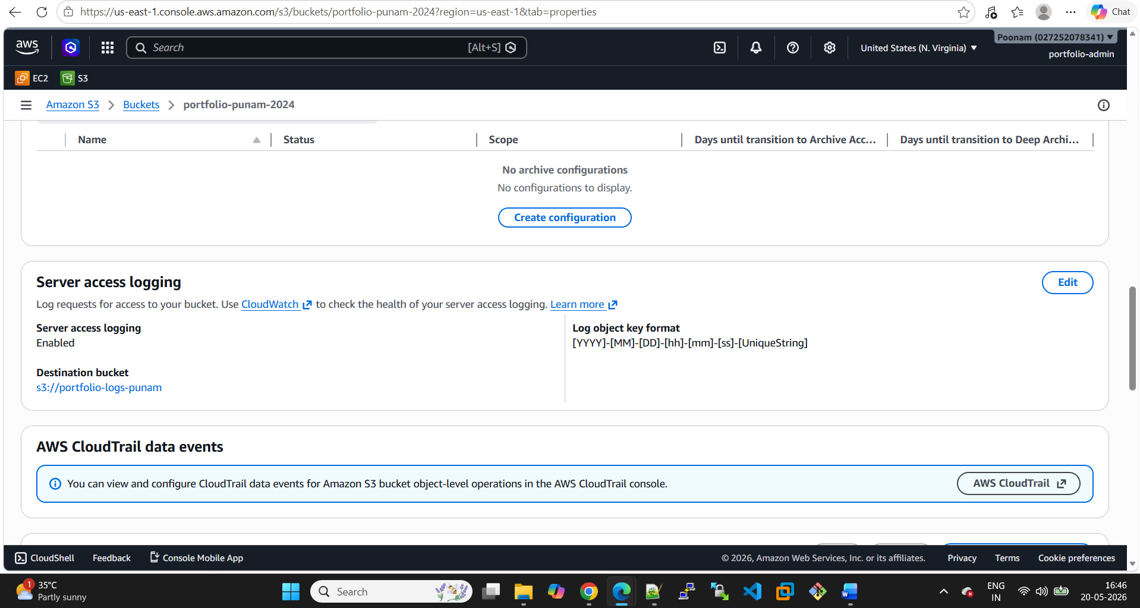

Bucket policy added

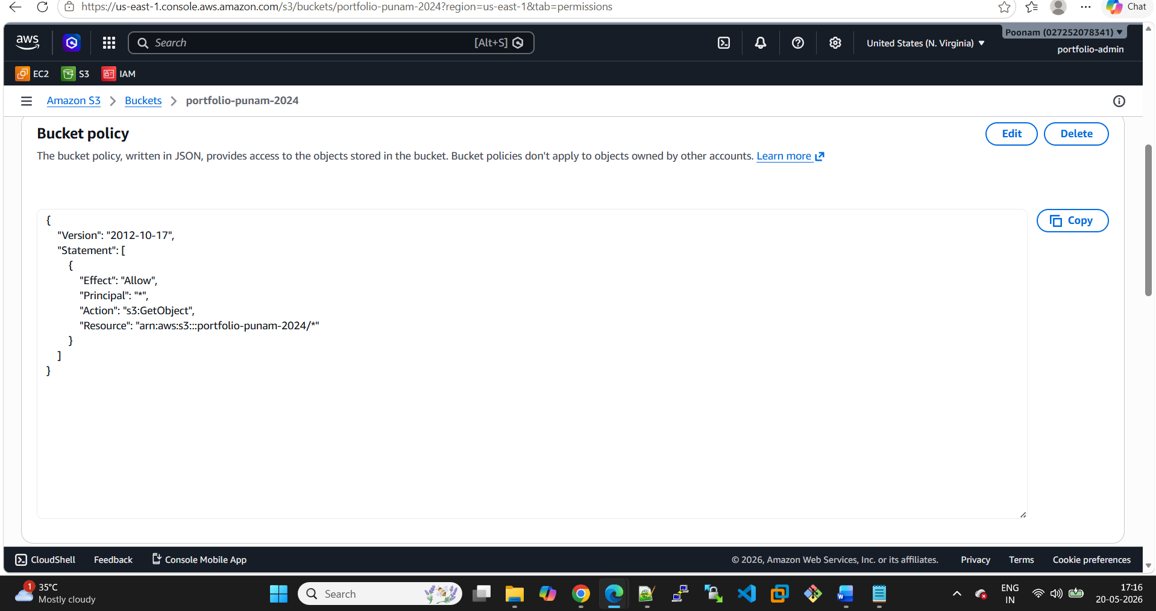

Website hosted
Bucket endpoint URL
http://portfolio-punam-2024.s3-website-us-east-1.amazonaws.com
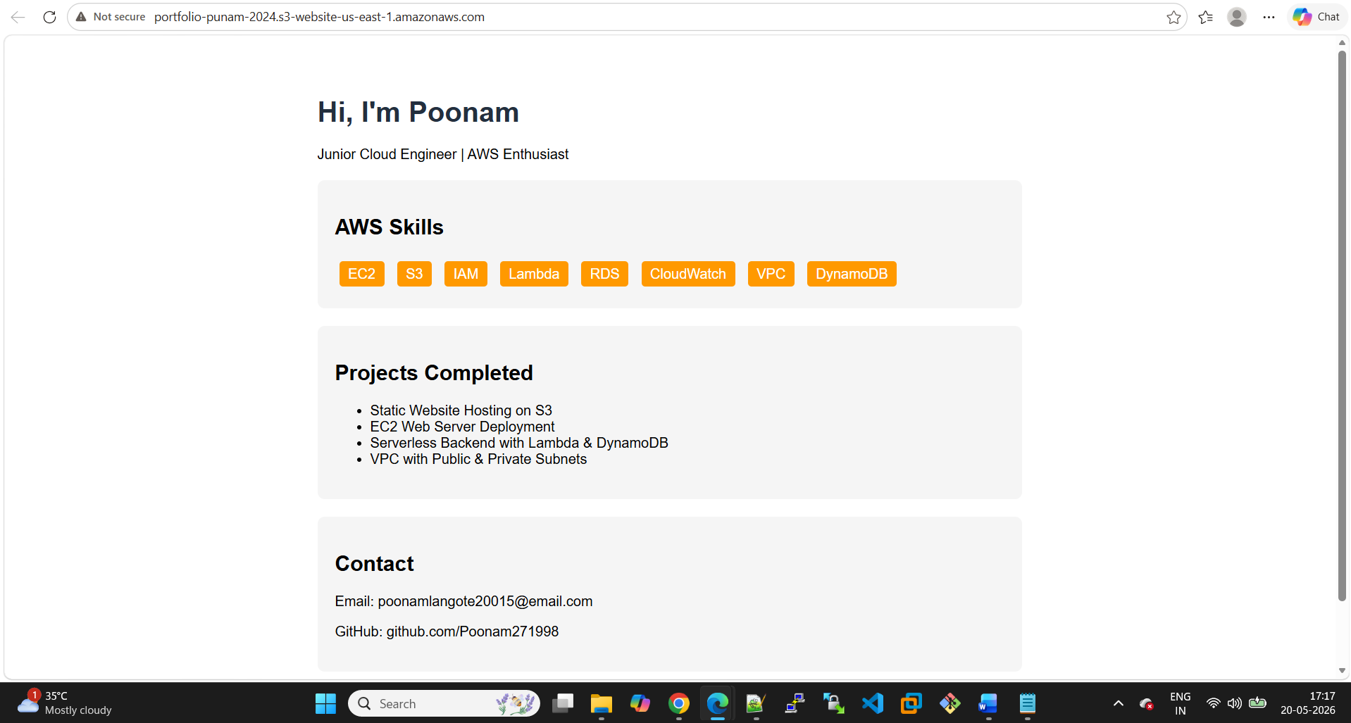

Showing versions
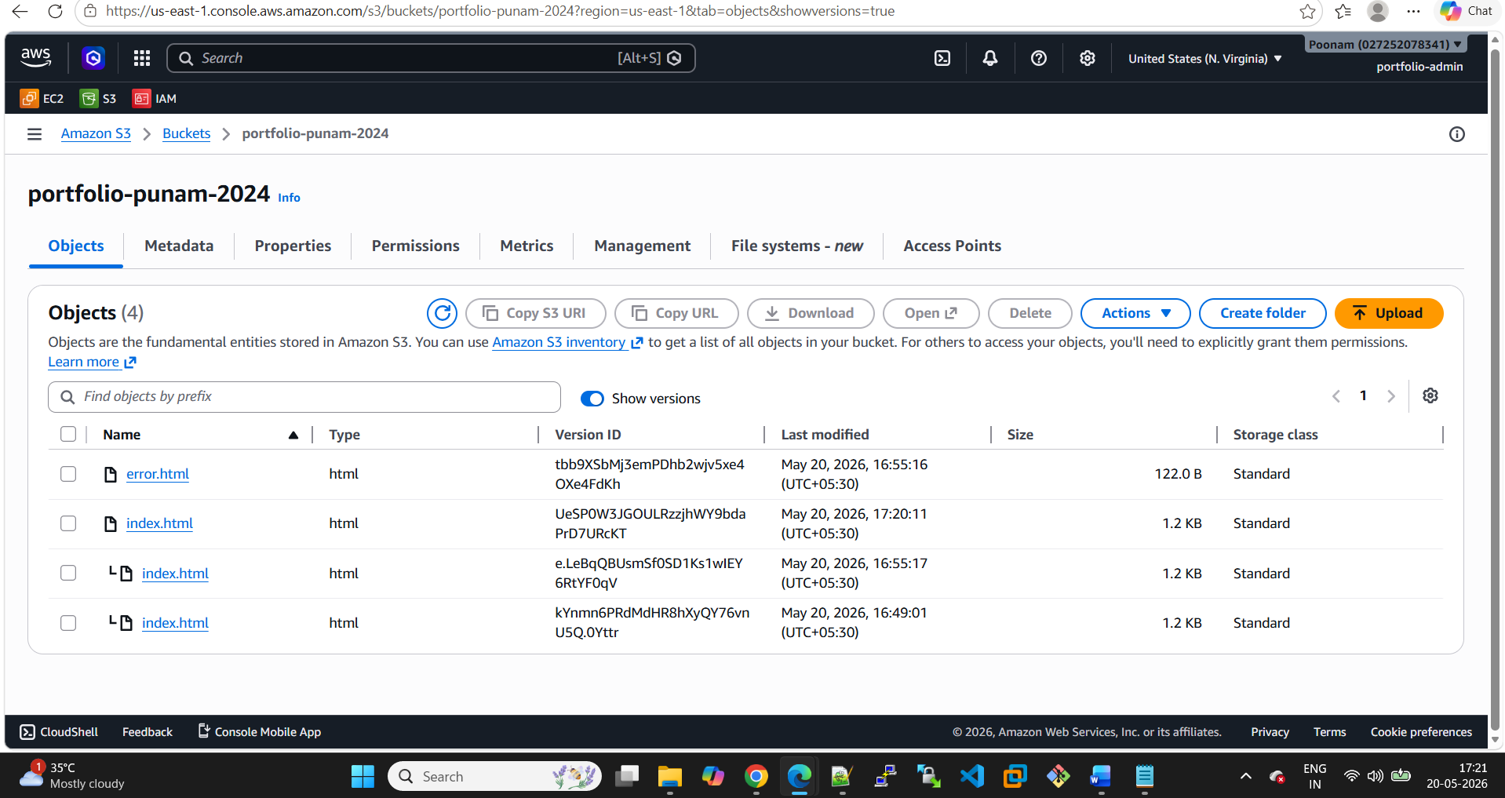
Email id changed
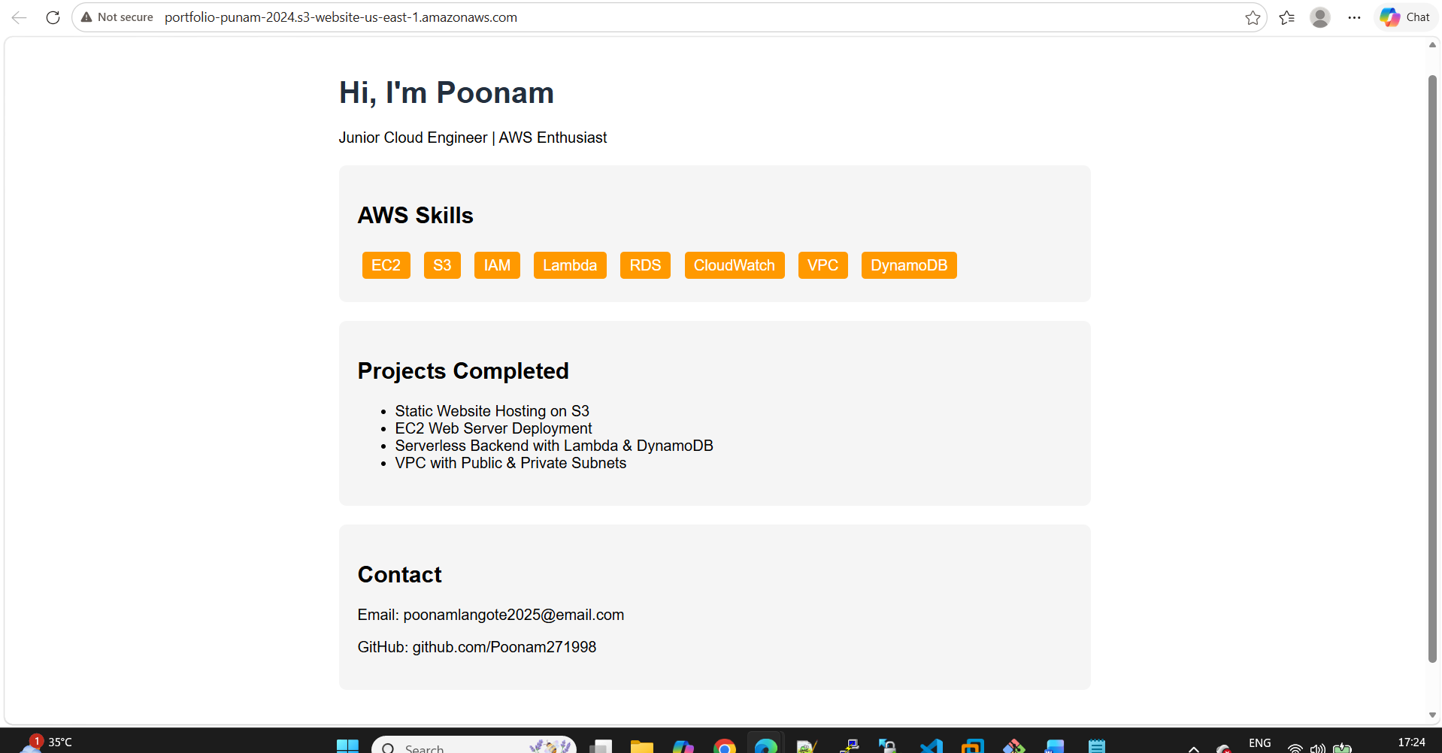
Subscription created in SNS
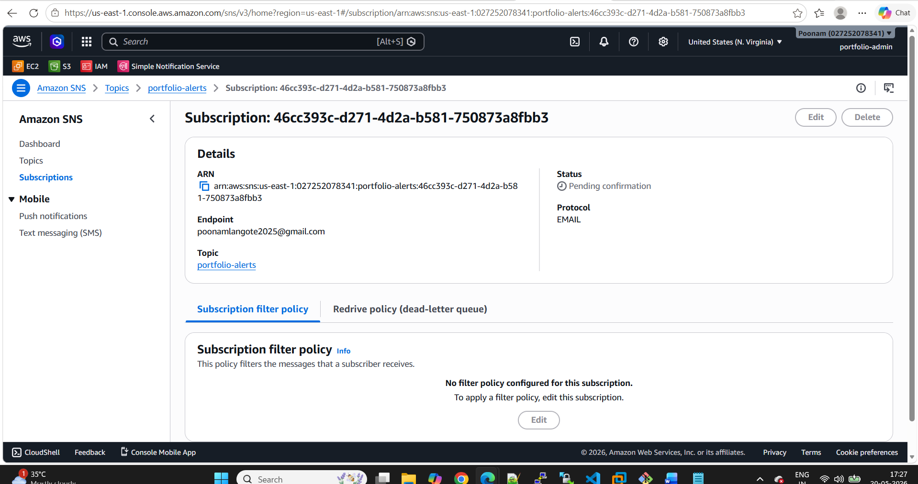
Cloudwatch settings
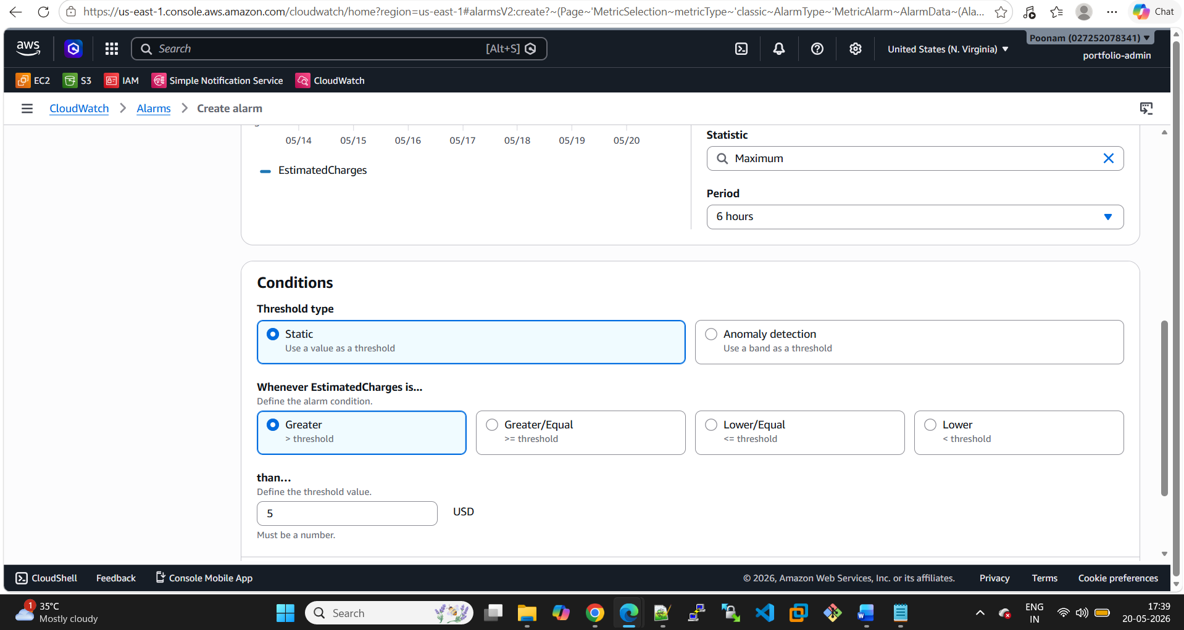
Cloudwatch billing alarm created
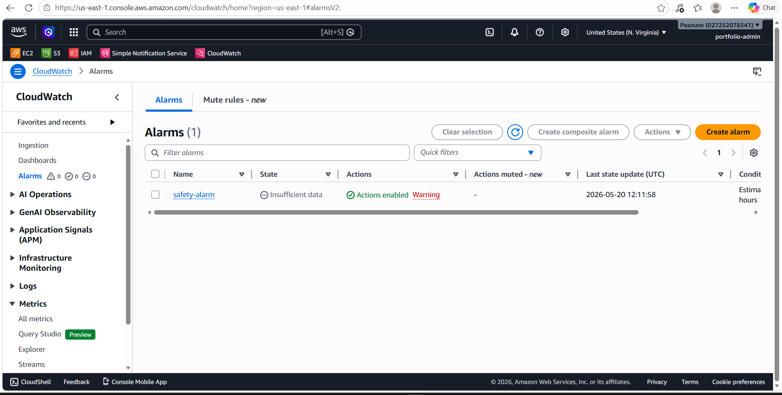
S3 bucket alarm
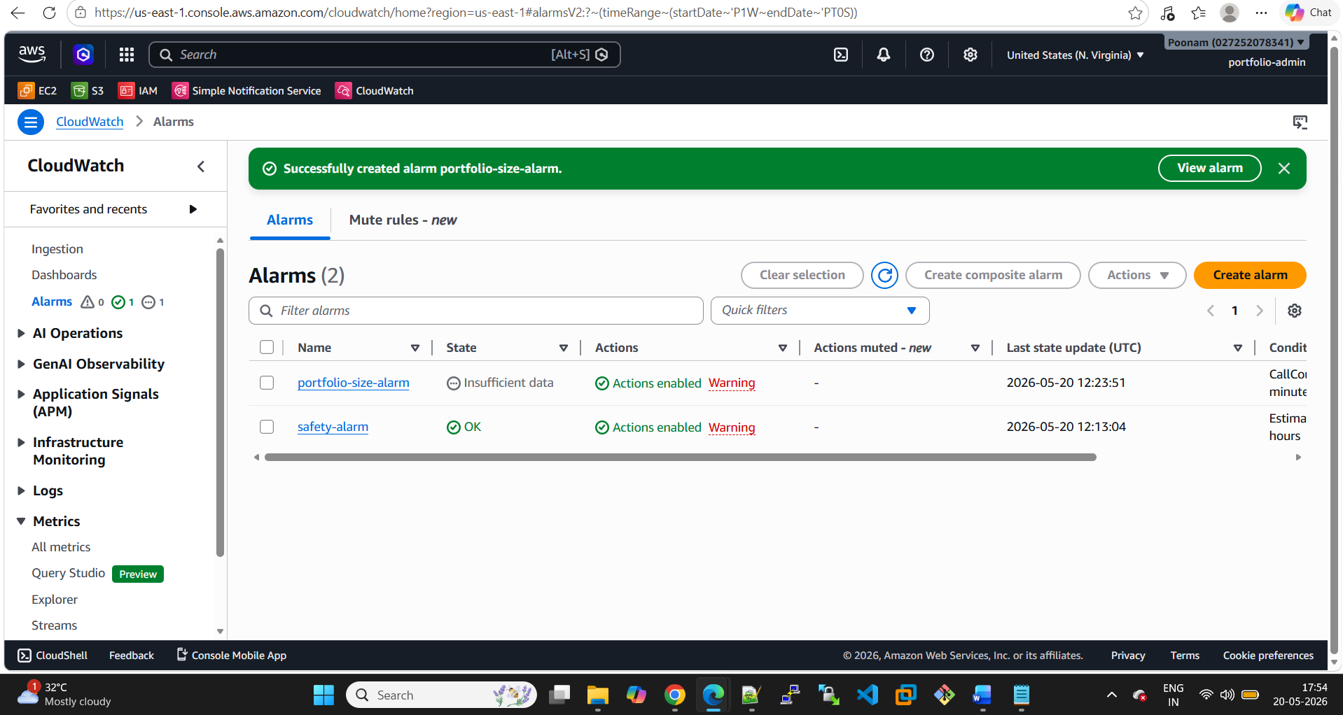

Dashboard created
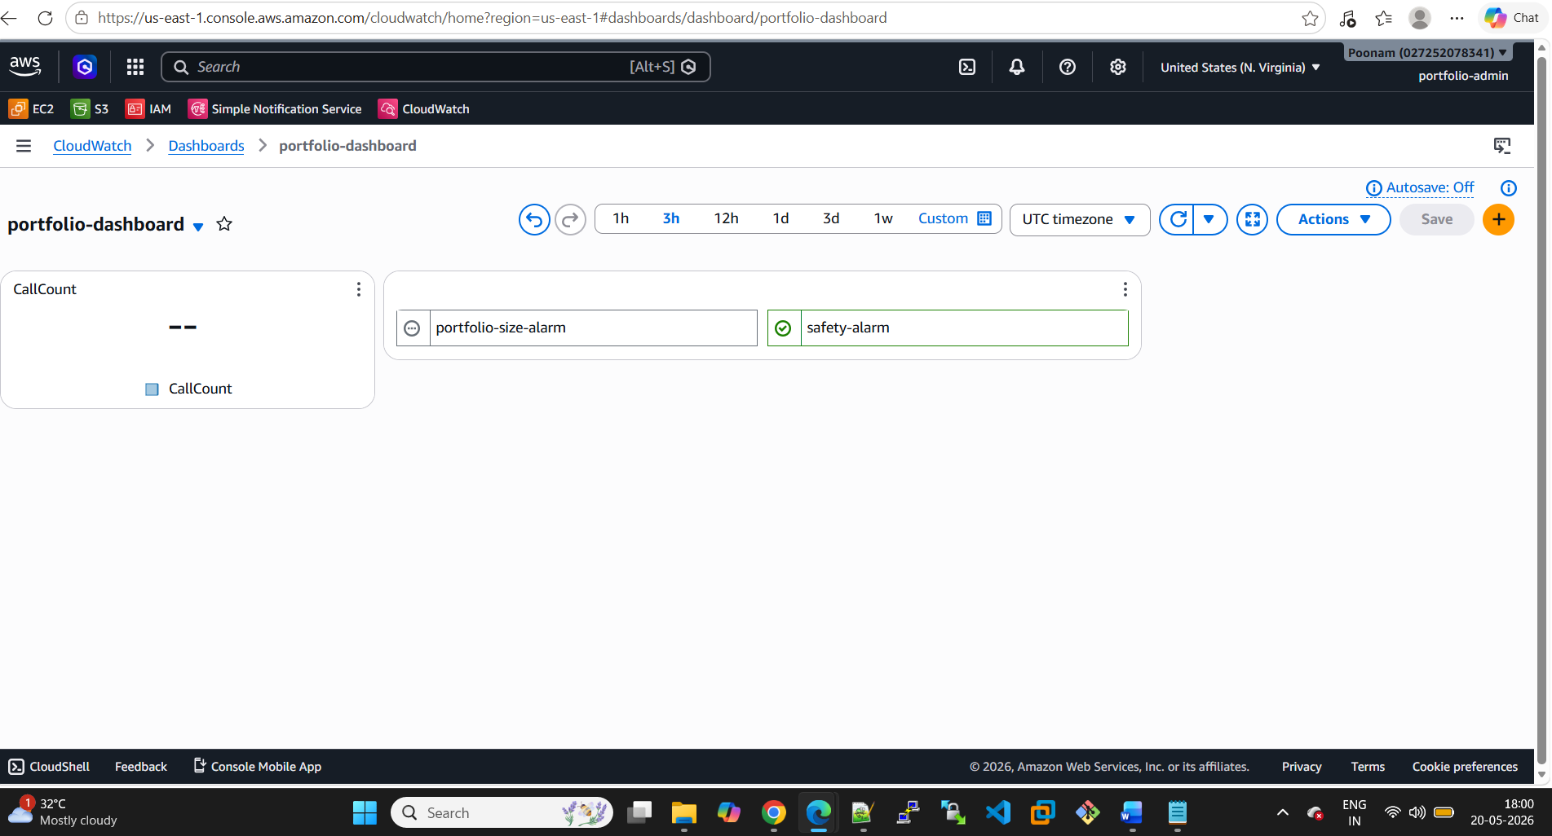
Cloudtrail created

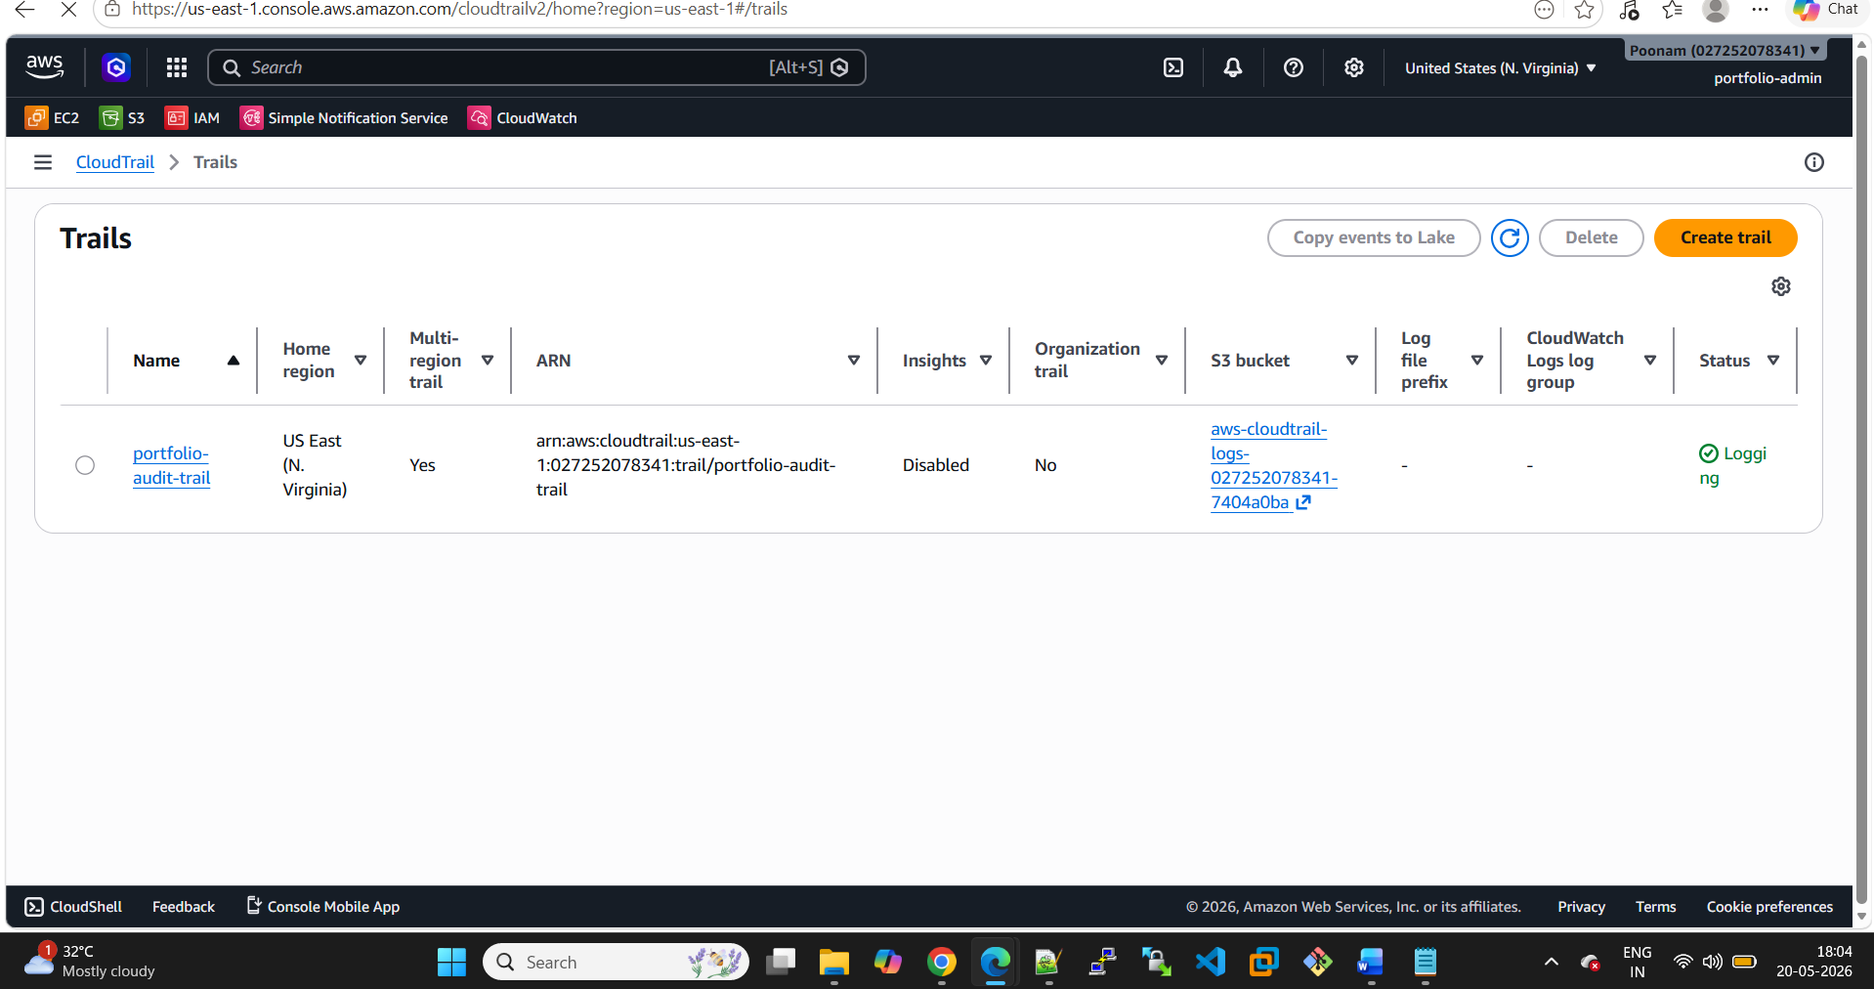
User deleted
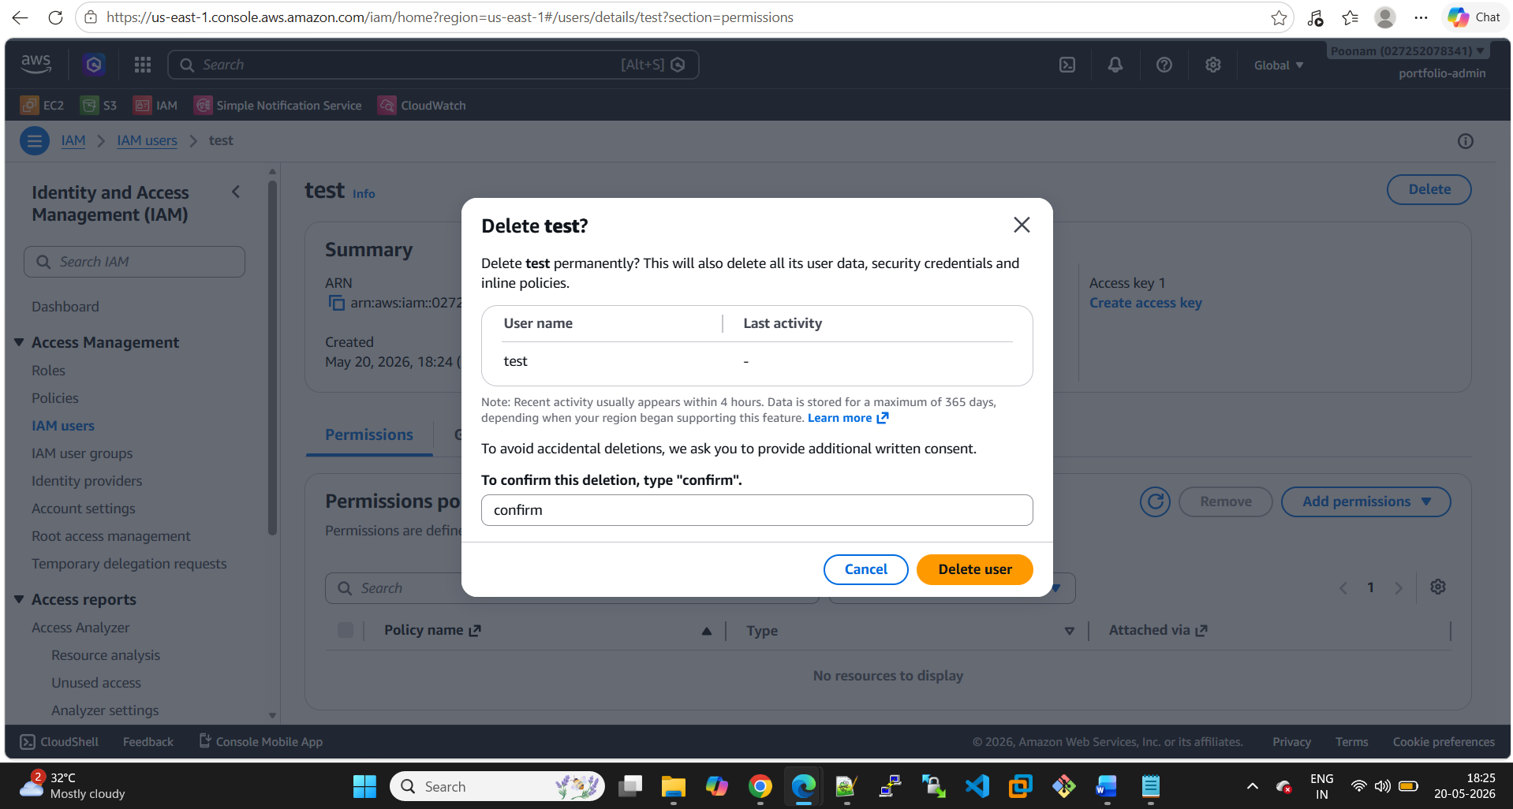

Cloud trail Event history
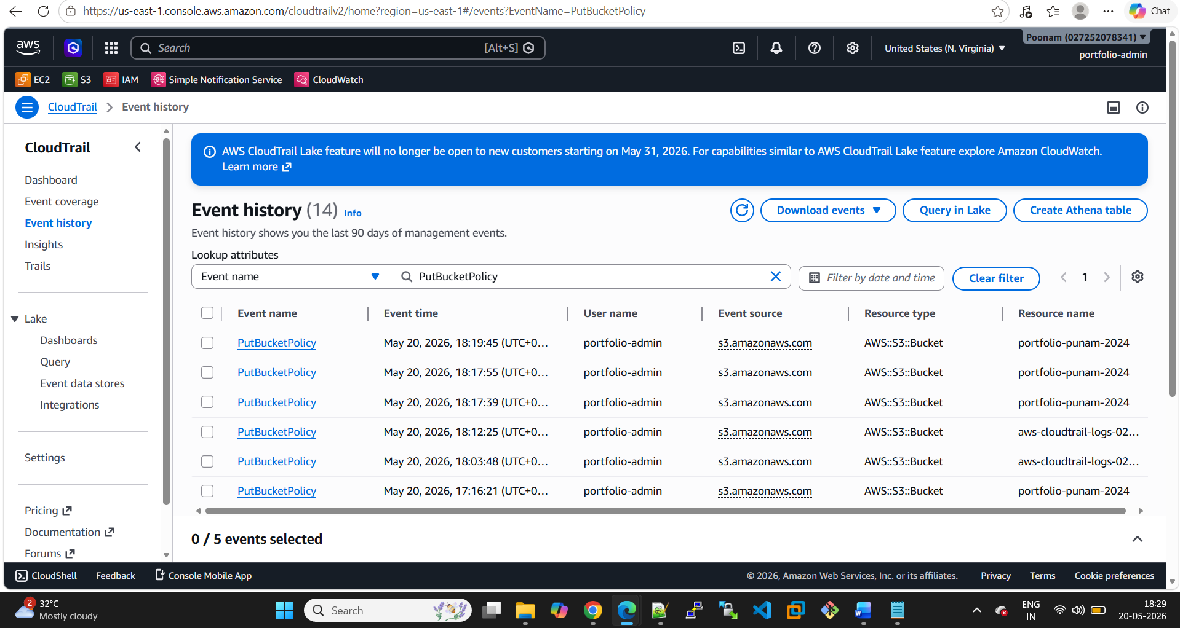
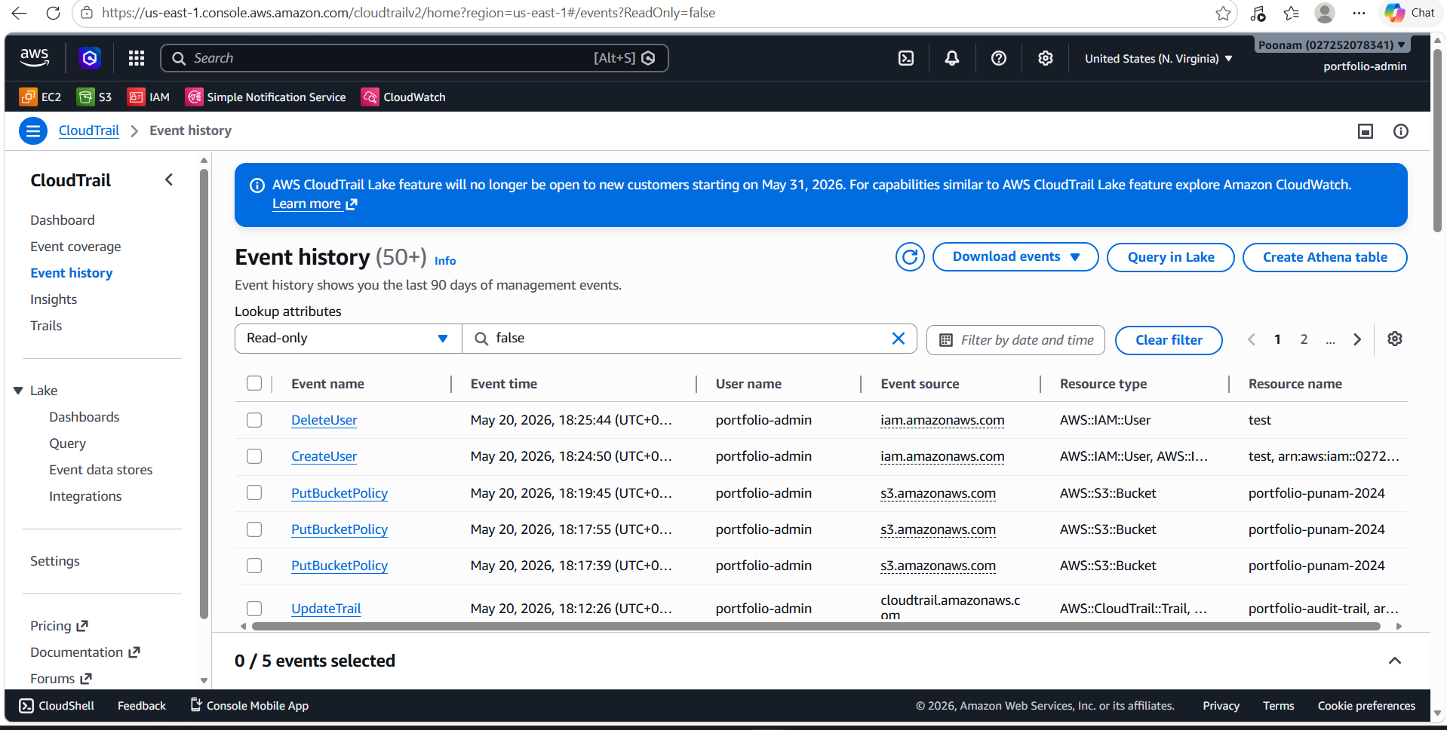

Trusted advisor logs
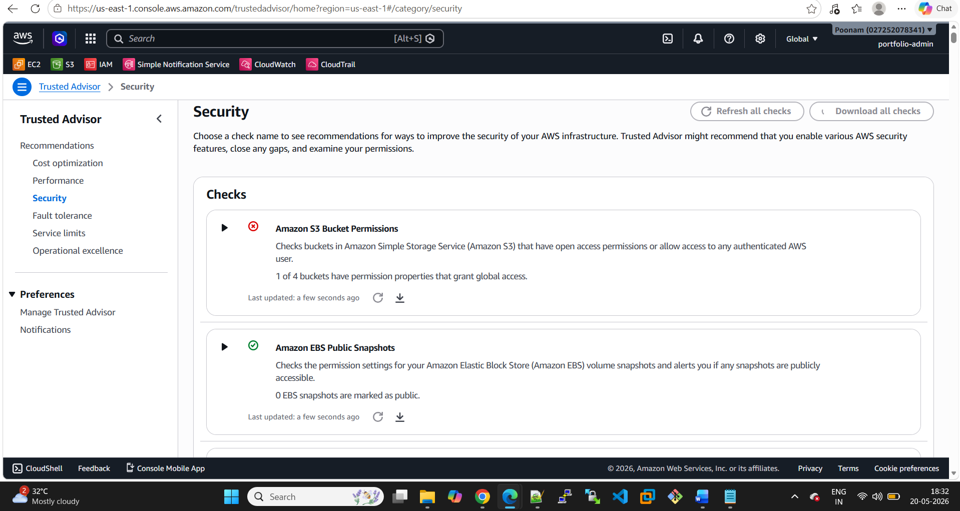

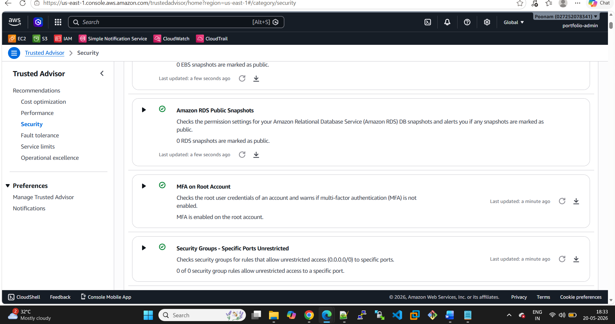
Budget created
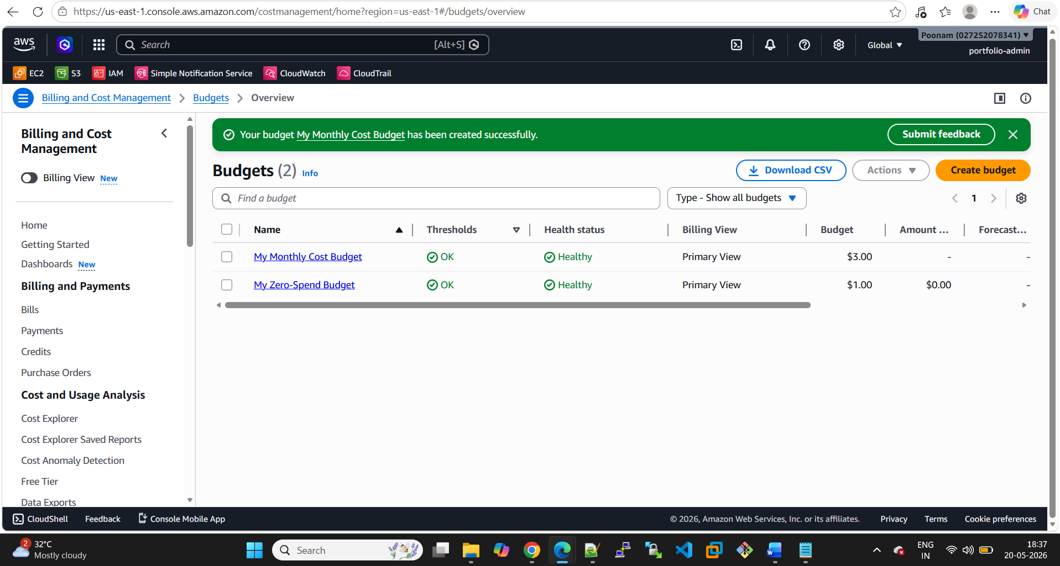

Cloudwatch
